A.F.S.
Access Flooring Supplies Ltd

Operating Instructions

Bandsaw AFS720

To assemble AFS720
lay machine on front face.
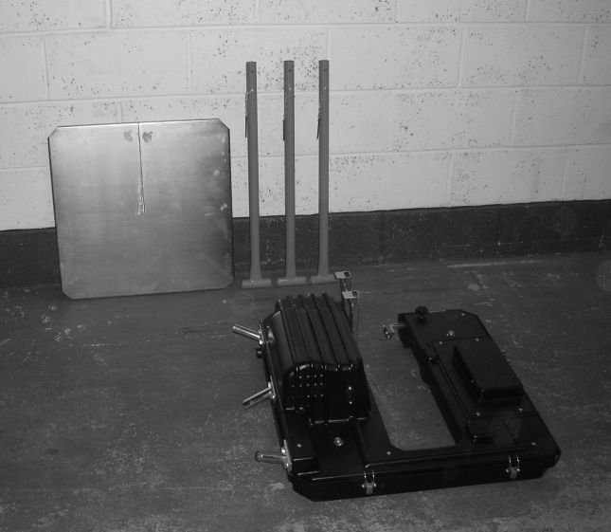

Fit two rear facing legs.

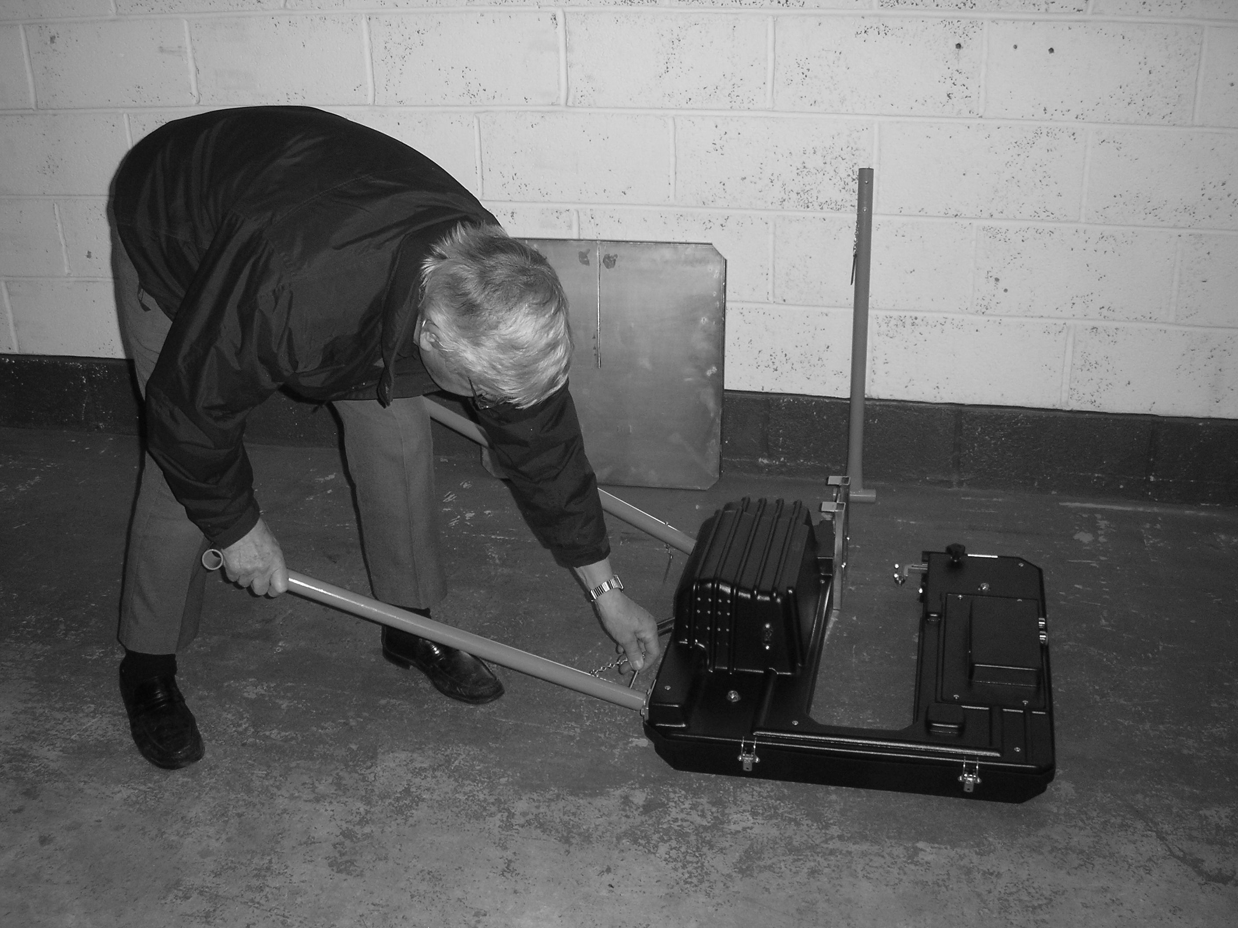

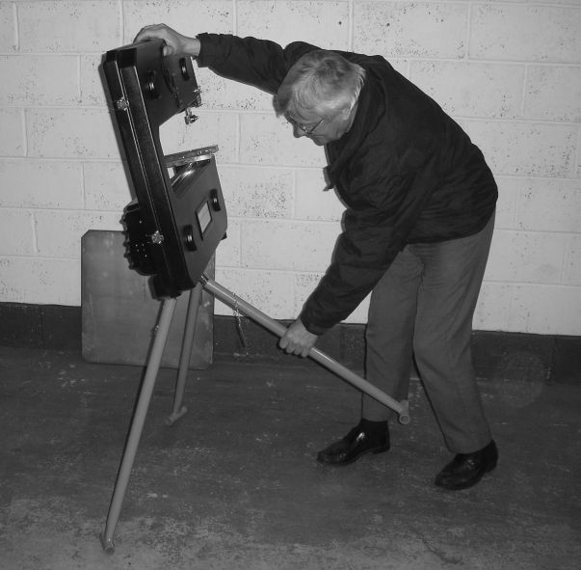
Lift machine and fit
the front facing leg.

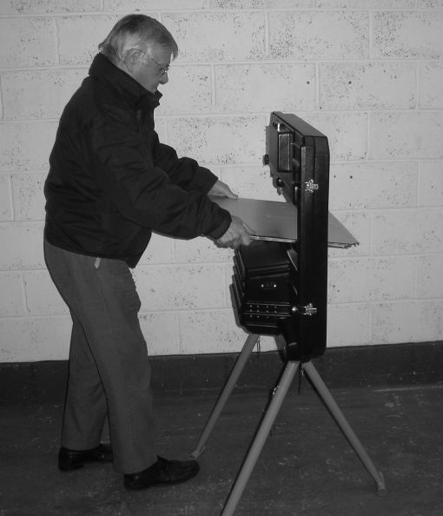
Fit table from rear
of machine.

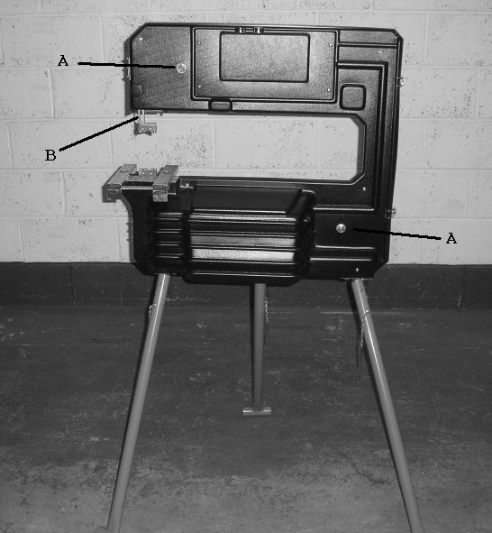

A = Tracking Screws
B = Adjusting Top Blade Guide

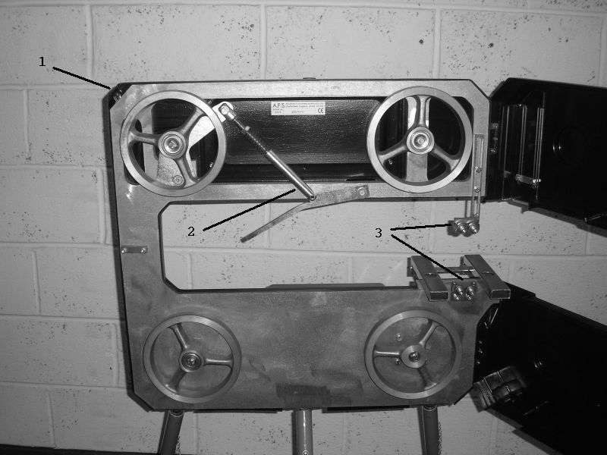

1 = Cover Microswitch
2 = Blade Tension Assembly
3 = Blade Guide Bearings
In the event that the bandsaw requires the blade tracking, stand behind bandsaw and override microswitch (1) with a clip. Slacken off nuts on the adjusters (A) and adjust tracking with Hex key.

General Safety

This equipment has been designed for use by an able-bodied adult. Anyone with either temporary or permanent disability must seek expert advice before using it.
Keep children, animals and bystanders away from the work area.
Never use this equipment if you are ill, feeling tired or under the influence of alcohol or drugs.
This equipment should only be operated by a competent person.
There is a serious risk of personal injury, use this equipment with care.

Safety goggles MUST be worn when operating this equipment.

Some materials, when cut, contain substances which, when inhaled, can be harmful to your health. A suitable mask must be worn when using this equipment.

This equipment produces a Sound Power Level of 89.5db. Ear defenders must be worn when cutting material.

Wear practical, protective clothing and footwear. Avoid loose clothing and jewellery that could catch in moving parts, tie back long hair.

Always disconnect equipment before moving it or making adjustments to it.

NEVER start the equipment with the blade in contact with material to be cut.

Ensure the work area is well lit and adequately ventilated.
Do not work near flammable gasses or liquids.
Always switch OFF and unplug equipment when not in use. Never leave it switched ON and unattended.
Never pull the equipment by its power lead.
Never remove or otherwise interfere with any safety guards fitted to the equipment.
Never use the equipment to cut asbestos sheeting, it may yield hazardous dust.
Keep your work area tidy, do not work in areas where you are standing on loose debris or on a slippery uneven surface.
Always ensure the blade guard is correctly adjusted and secure before starting work.
Always take care when fitting new blades – They are sharp!
Always fit new blades with the teeth facing down.

Operating Techniques

This equipment is fitted with an NVR (no volt return) switch, if the power supply is interrupted the machine will switch OFF and will need to be switched back ON once power is restored.
If this should occur during a cutting operation DO NOT switch back ON until the material being cut has been removed.

Lower the Adjusting Top Blade Guide (B) so that it is approx. 5mm above the thickest part of the material to be cut then tighten securely in position.

Lower the Blade Guard by loosening the 2 wing nuts at the front of the equipment, to leave the minimum amount of blade necessary to make the cut.

To START the machine, push the Green Start Button, if the machine does not start check power and all connections. Try again.

To STOP the machine, press the Red STOP Button.

Always start the machine and allow the blade to get up to speed before bringing the material to be cut into contact with the blade.

Adopt a stable stance that gives a good view of the off-cut whilst keeping you clear of the bandsaw blade. In particular, avoid placing your hands and fingers close to the blade.

Holding the material to be cut firmly, guide it into the blade using any pre-marked cutting line, using just enough pressure to ensure reasonable progress.

If the material is narrow or small, push it through the blade using a piece of waste timber. NEVER allow your hands or fingers to get close to the moving blade.

Remove the work from the cut before switching OFF and wait for the blade to stop before clearing any waste off-cut.

Replacing The Blade

Make sure that the machine is switched OFF and unplugged, fit the machine with the correct blade for the job.

Undo the 2 cover clips on the left hand side of the body and swing the front cover open, to reveal the 4 guide wheels.
Lower the Blade Tension Assembly (2) then place the blade around the 4 guide wheels, ensuring the direction of cut is correct (teeth facing down) and that it passes between both upper and lower blade guide bearings.

Raise the Tension lever and check again that the blade is correctly positioned and at the correct tension (spring should NOT be compressed to less than 50mm). Then close and clip the front cover in position.

Because bandsaws cut on the ‘downstroke’, the materials lower face may be marred by chipping or splintering, but it is still best to cut with the work face up.

Equipment Care

NEVER force the work through the saw. If it jams in the cut, switch OFF, free it and check the blade for damage before carrying on.
Regularly clean out the machines ventilation holes. If these become clogged with dust and debris, the machines motor could overheat.
Never work with a blunt or damaged blade. It not only produces poor work but could overload the machines motor.
When cleaning or changing blades remember to switch OFF and unplug the machine.
When not in use store the equipment somewhere clean, dry and secure from thieves.
NEVER over-tighten nuts, knobs and screws when making adjustments, particularly when adjusting guides and guards, you could damage the machine.
Never use the machine to cut nail/screw embedded wood, unless the blade fitted is designed to do so.

End Of Work

Switch the machine OFF and unplug from the power supply.
Remove the table and the legs.
Give the machine a final clean ready for the next job.

